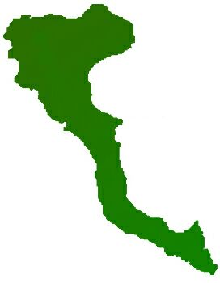

|  |  |
| --- | --- |
| **Team: 3-D Protocol number: 3** | |
|  | |
| **Author:** Arenas Pérez, Pedro José | **Date**: 27.11.2020 |
| **Place:** MS Teams at 14.35 hrs. |
| **Participants:**  - Adnan, Muhammad  - Arenas, Pedro  - Ashar, Shazeem  - Shahid, Arsalan  - Ur Rehman, Mutee | |

| **Protocol of the meeting of 27 November 2020** | | |
| --- | --- | --- |
| **Topic** | **Results** | **Time** |
| Tasks | Mr. Arenas & Mr. Shahid will work mainly in backend development. The rest will work mainly in frontend tasks. | 15 min |
|  | Mr. Arenas will design first DB schema and prepare Docker container with instructions on how to use | 15 min |
|  | Mr. Adnan, Mr. Mutee ur Rehman, Shazeem Ashar will work on Front-end application, that will be in Angular. | 15 min |
| Project decisions | Speciality will change to Adaptive App | 5 min |
|  | New team leader until 1.12 will be Mr. Adnan | 1 min |